Good E(a,b)

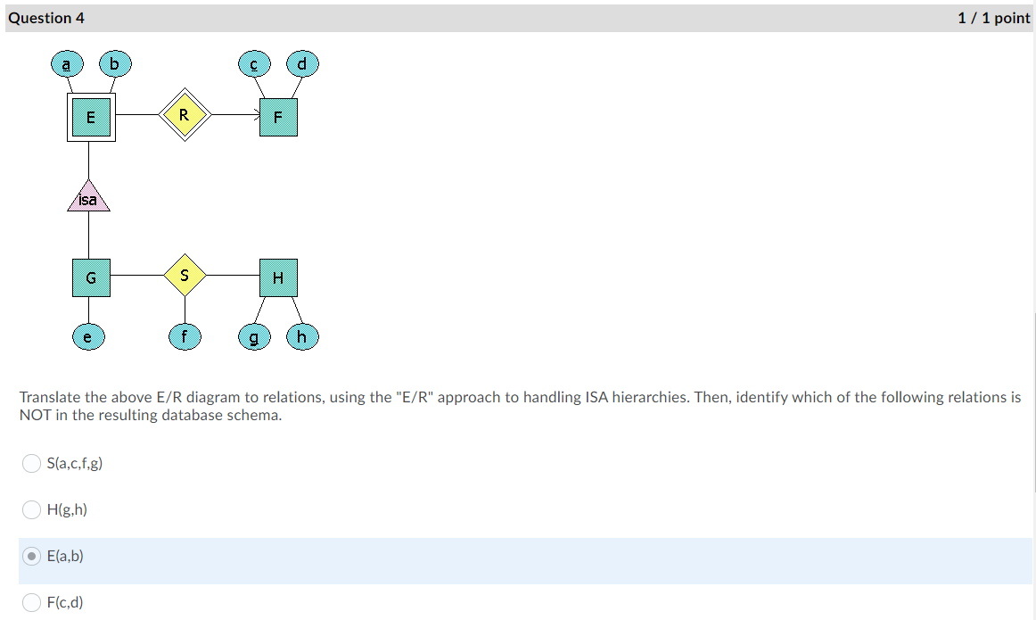

Good

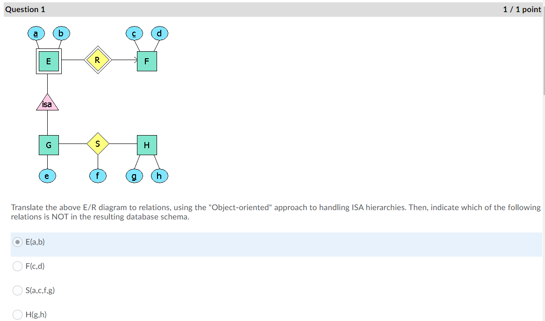

Good E(a,b)

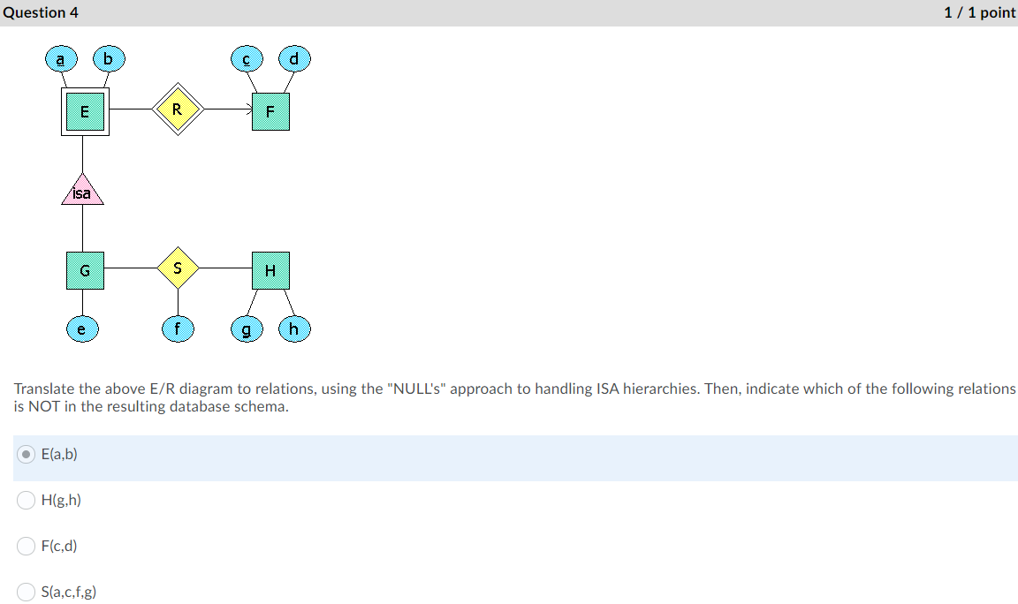

Good

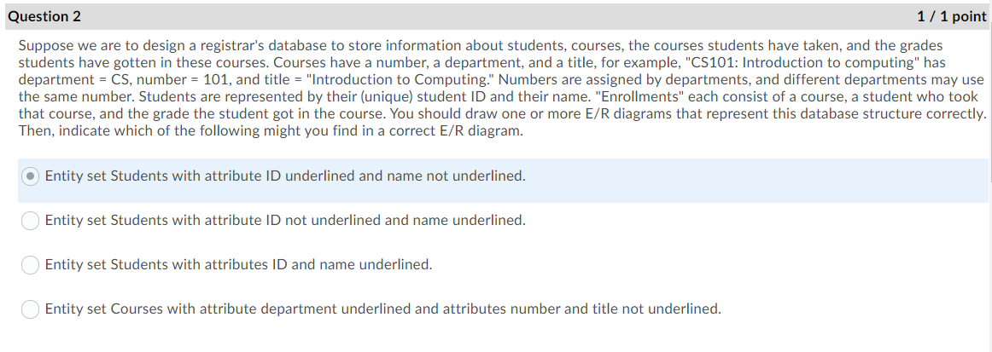

Q must be an oval labeled account or a rectangle

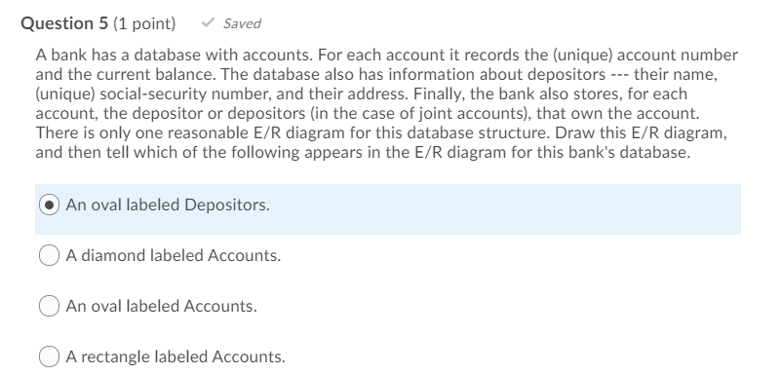

An oval labeled Depositors

A diamond

Q must be pianoModel(manfName, type, price)

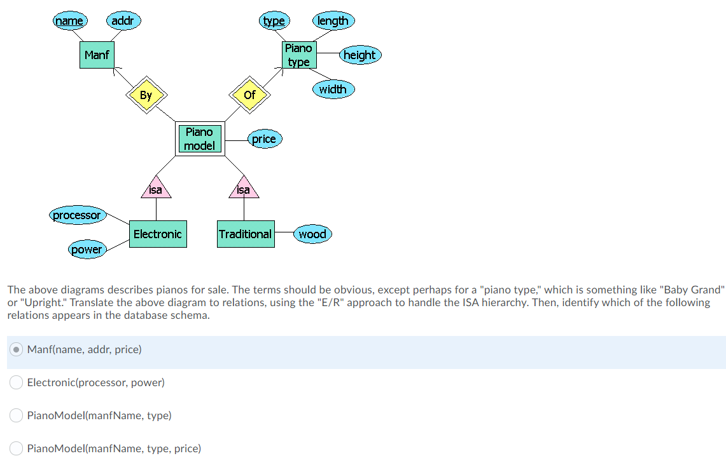

Man

Piano model

Electronic

Good

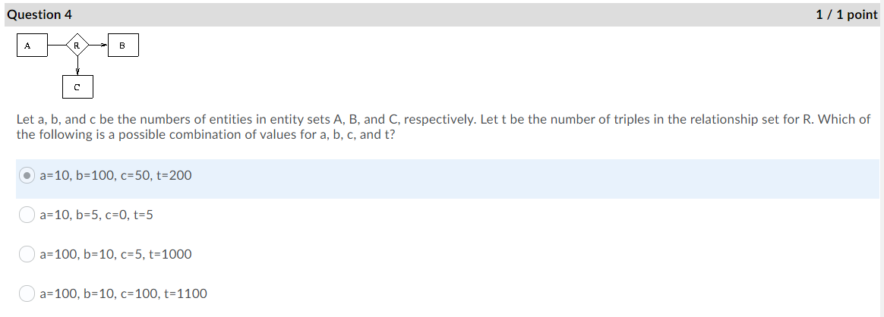

Q. must be R(a,b)

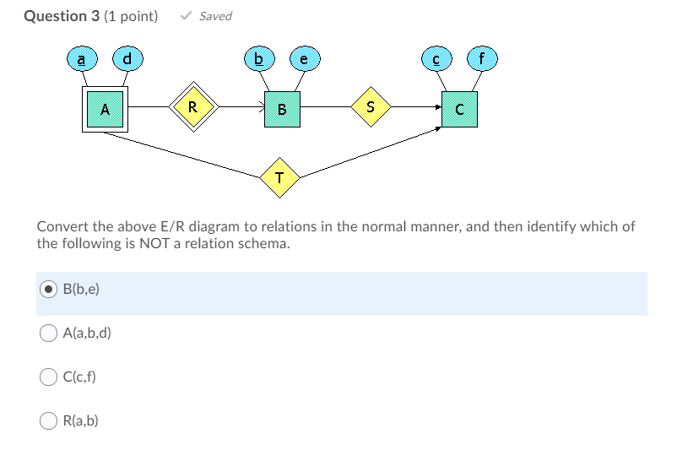

B(b,e)

C(c,f)

A(a,b,d)

Good A=0, B=0, C=0

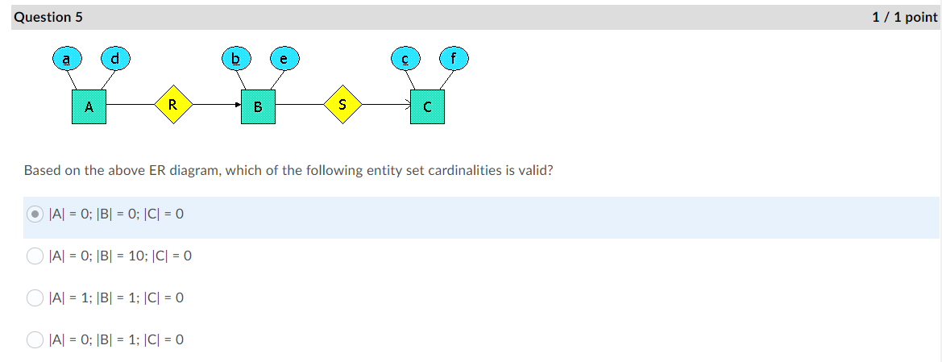

Good S= b1,c1 , b2,c2

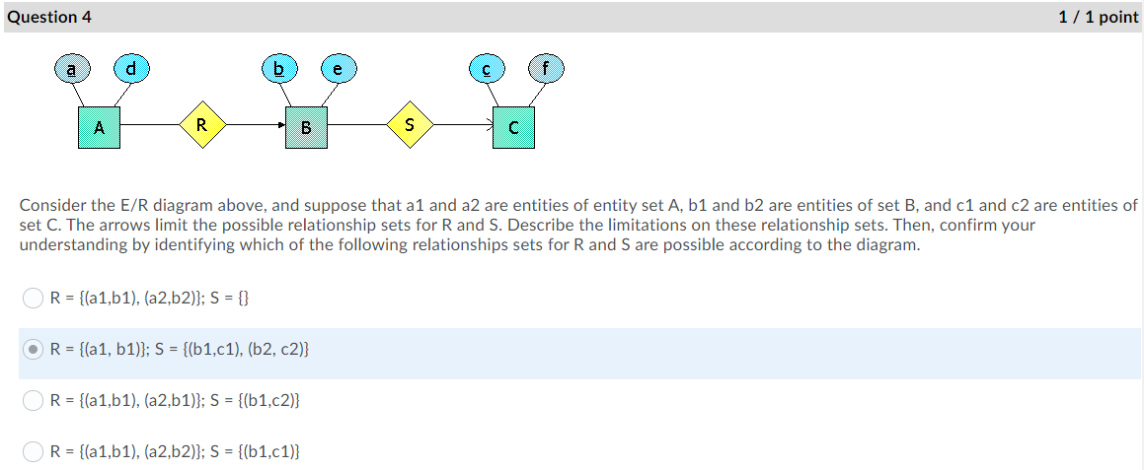

Q. Good

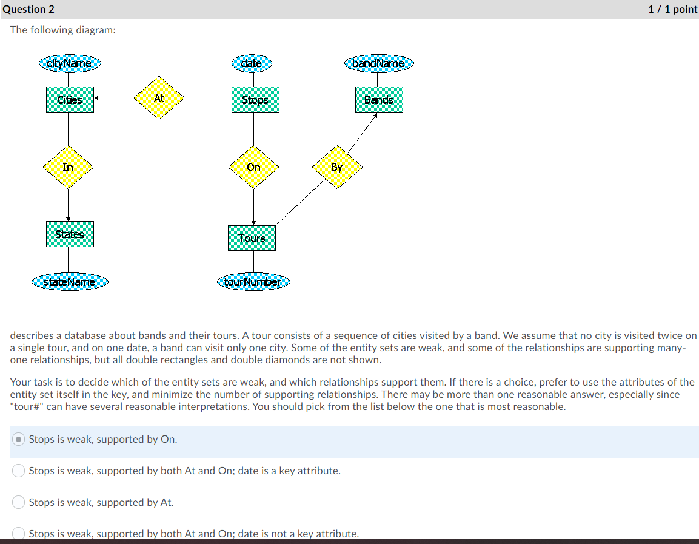

Q must be Cities(cityName, stateName, mayor),States(name,governor)

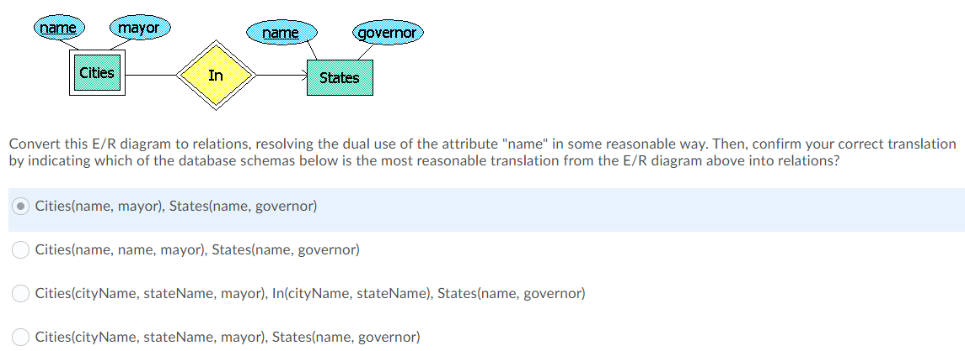

Cities (name, mayor), State(name, governor)

Cities(cityName, stateName, mayor), In(cityName, StateName), State(name, gorvernor)

Cities(name, name,mayor), States(name, governor)

Good

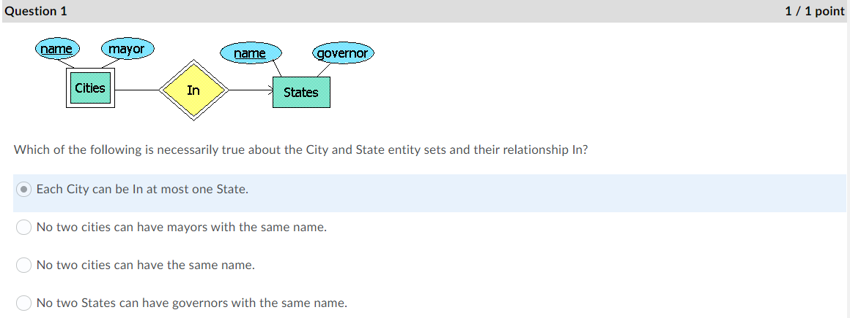

Good. B(d,f)

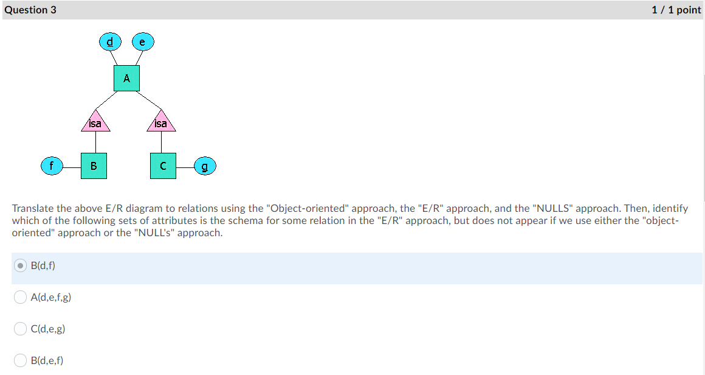

Good

